PREDICTION OF non-linear SYSTEMS BEHAVIOR USING PROBABILITY MODELING

Pavol Kurdel¹, Marek Ceskovic¹, Anton Panda^{2,3}, Natalia Gecejova¹
¹Faculty of Aeronautics, Technical University of Kosice, Rampova 7, 0401 Kosice, Slovak Republic
²Faculty of Manufacturing Technologies with a seat in Presov, Technical University of Kosice, Bayerova 1, 080 01 Presov, Slovak Republic
³Institute of Technology and Business in Ceske Budejovice, Faculty of Technology, Department of Mechanical Engineering, Okruzni 10, Ceske Budejovice, Czech Republic
DOI: 10.17973/MMSJ.2026_03_2025116

e-mail: anton.panda@tuke.sk
The article focuses on optimizing the transmission and processing of information within airport information systems. To solve this problem, it is necessary to know the absolute information flow and the method of signaling emergency conditions, which complement the overall reliability of the systems and also have an economic impact on their operation. Using logit models and prognostic simulations, the hierarchy of weights of various types of airport information that affect the safety, smoothness, and operational readiness of the airport is analyzed. The research focuses on identifying critical paths in information flows, their delays, and the probabilities of failure of individual airport systems. Another important element is the observation of other factors in the area of technology optimization and the implementation of backup solutions, which are key to increasing reliability and minimizing the risk of operational failures. The presented model provides a framework for decision-making in the optimization of airport information systems from both a technical and economic point of view, which can significantly contribute to increasing the performance and safety of the entire aviation infrastructure.

Keywords

Airport information systems (AIS), Optimization of information transfer, Reliability, Logit models, Simulation and forecasting, economic efficiency, Air traffic.

1 Introduction
An important aspect of solving and optimizing airport processes is their transition through optimization phases, which are the final residue of the use of artificial intelligence elements. If we get through all the modernization transitions, we can observe the airport itself in the process logic of electronic-technical elements. These elements are most often supplemented and replaced to speed up control information processes [Tutak 2024]. For these reasons, precise airport management is already an important node of logical operations that must be taken into account through information flows that are within the tolerance of their own limiters and limits (Fig. 1) for a smooth transition from unstable to stable information regimes [Kurdel 2018].
The airport ergatic system (AES) expresses the position of a person H of his technical activity M in the airport environment E, which is surrounded by the entire electronic-technical part to maintain it in a state supported by airport documentation. The input of the operability of aviation information systems into the technically controlled environment as a quantity X(t) which is processed by the stabilization circuits LW and LM (see Fig. 1).
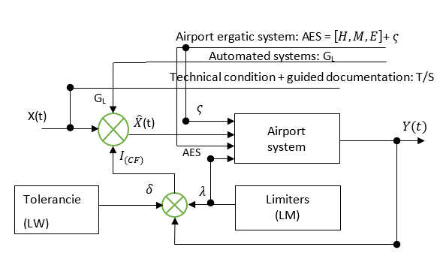
Figure 1. Global technical non-linear system for airport stability
Errors (errors$ξ$ ) are deviations from the technical state and controlled documentation that technology cannot exceed with its progress:
$G=m .\overline{g} ±δ_{g}$ | (1)
​ $g$ - the average value of the global airport space (e.g., the average statistical value from the observed airport data) , it is not a fixed value, but varies within a statistical interval
$g∈\left[0,1\right]$.
$δ_{g}$ - deviation (tolerance) of the influence of airport space on the airport information system (e.g., standard deviation or specified uncertainty interval);
G - the resulting effect of the airport information system (e.g., performance, stability);
m - Airport as a factor (capacity, size, type of infrastructure).
The stability $g$ acting on the system is in the range of statistical values ​​0 - 1. The addition of the deviation $δ_{g}$to the system affects the information value$I$ the most$. λ-$ (values ​​determined by the IS manufacturer) has an impact on the information value $I$. This allows us to introduce a correction term CF based on LW and LM where δ is the deviation (minimum limit) and λ is the manufacturer-defined maximum limit of the information value:
$ΔI(g)=I_{0}+\left( λ- δ \right)g+I_{CF}$, $I_{0}∈ \left[δ,λ\right]$ | (2)
Where:
$I_{0}$ - original informational value;
$∆I(g)$ - increase in the influence of on information depending on the stability of space $g$,
The second condition for the informational stability of the AES system is constant dispersion. The stability of the AES system is directly dependent on the quality of the information flow, with its accuracy, speed, and reliability determining the system's ability to maintain balance and function effectively. Constant dispersion in the context of an airport refers to a situation where the variability (dispersion) of a certain variable, such as arrival or departure times, is constant over time [Guo 2020] . This can have significant implications for airport operations planning and management. In this form, it is then difficult to preserve the correction term that has an impact on the ergatics of the entire AES system.
$∆T_{CF}\left(g\right)= - α ∇I(g)$ | (3)
$∆T_{CF}\left(g\right)$- correction term influenced by the AES system and the stability of space $g$,
$α$ - intervention effectiveness coefficient (calibrated parameter according to the rate of information flow from AES).
$∇I\left(g\right)$ - gradient (change) of information value depending on the stability of space $g$ in which the airport object is located. Therefore, if we ultimately want to achieve If we want to ensure constant dispersion $σ$, it is necessary to:
$$Var\left(T_{i}\right)= σ^{2}=konstanta V_{i}$$ | (4)
The time dispersion between arrivals (or between arrival and departure) is constant, which means:
- interventions must not introduce additional time variability into the system $T_{i}$ ,
- information system is mainly used to reduce or stabilize logical deviations at airports $Vi$ .
We talk about time constant because each airport has its own time for AES [Lazar 2018].
This perception of airports with internal processes for receiving aircraft must correspond to the importance and needs of airlines operating aircraft to minimize downtime at airports and check-in processes. Airport management systems apply management phases in which the entire process of information flow processing in airport processes results in a steady-state response [Kovacikova 2023]. Currently, with the advent of machine learning and Markov decision processes, the transition to fully automated processes with an observing human factor is unsustainable [Liu 2023, Panda 2014 & 2021, Pandova 2020, Panda 2020 & 2022, Harnicarova 2019, Sukhodub 2019, Nahornyi 2022].

OPTIMIZATION OF WEIGHT INFORMATION WHEN CHANGING AN AIRCRAFT DEPARTURE
Through effective airport optimization (smart technology), airports can balance available resources and reduce aircraft delays. This can only be achieved through effective information optimization. Using algorithms that respond to real-time variables such as flight schedules, gate availability, and even weather changes, we can dynamically adjust flight operations to meet the changing demands of a given airport. Simulation models play an important role in testing these optimization strategies under different conditions [Cavada 2017]. For example, an airport can simulate different weather scenarios to see how delays affect passenger flow and overall operational efficiency. Similarly, by changing the order of flights and testing different boarding approaches [Kovacikova 2024] .
Network optimization specifically focuses on determining the best possible routes and flight schedules for airlines in order to minimize travel time and fuel operating costs while ensuring passenger satisfaction and safety. With advanced data analytics and AI techniques, airports can better predict demand patterns and allocate resources more efficiently. The use of simulation theory, airport models, and network optimization techniques creates a powerful framework for increasing airport operational efficiency. Transportation authority’s responsible for overseeing aviation safety can significantly improve wait times and optimize resource utilization by applying these methodologies [Andronie 2018, Remencova 2021].
This comprehensive approach benefits not only the immediate airport environment but also contributes to the broader sustainability and resilience of the airport in the face of growing travel demands [Shone 2021] .
The design of the mathematical model assumes that the information flow monitoring system $Up(s)$ - shows no delay. Let Up represent the control input for any receiver or transmitter (P/O) of processed information from airport systems. The output from the airport facility and display and information portals is the signal $Xd$. The reason for this is that the P/O function is characterized by a time delay $K_{0}$, whose magnitude is $s$. During the time delay, the $P/O$function opens the output from the Xd(s) system, which is described according to the block diagram in Fig. 2.
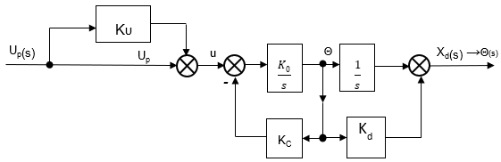
Figure 2. Scheme for receiving and sending information from/to airport systems
$K_{0}$, $K_{U}$, $K_{C}$, $K_{0}$, $K_{D}$: are the parameters of the airport system, probably the constants of feedback, amplification, or dynamics
The denominator indicates that this is a second-order system, which means that the system has two poles and may exhibit variable behavior. The numerator $K_{0}=(1-K_{U})$ determines the amplification of the system. The input $Up(s)$ is airport information that performs an information operation in the form:
$$\frac{X_{d}}{U_{p}}\left(s\right)$$ | (5)

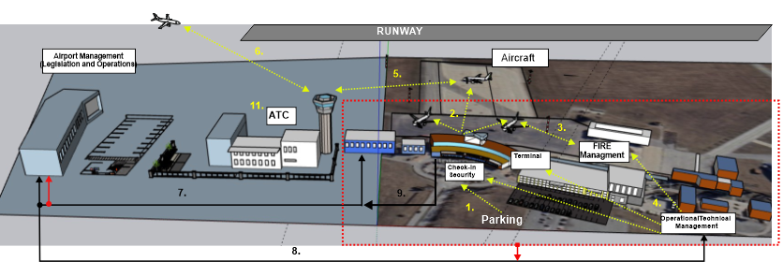
Figure 3. Model 3D illustration of Kosice Airport with ongoing information flows.
1. Passenger movement to the terminal, 2. Passenger movement (after security check) to the aircraft, 3. Technical staff workplace for aircraft, 4. Control workplace for operational management of the terminal and aircraft on the apron, 5. Communication between ATC and aircraft on the apron, 6. Aircraft communication for airport approach (CTR), 7. Airport supply management logistics, 8. Communication flow with airport operations and sections, 9. Feedback from the airport's operations and technical department. 10. Airport information systems

Transfer function that forms the overall data information logic
$⋁i$ see formula (4):
$G\left(s\right)=\frac{X_{d}(s)}{U_{p}(s)}=\frac{K_{0}(1-K_{U})}{s^{2}+K_{0}K_{c}s+K_{0}K_{d}}$ | (6)
In formula (6), $K_{d}$ is a time constant that is given for information flow processing and is assigned for signal processing by standard airport information means. Based on the information transmitted from any airport information device, it is necessary to find the optimization and its weight for further evaluation of its importance. It is necessary to improve the efficiency and accuracy of information transmission from airport information devices by optimizing the transmission of information from airport information devices [Liu 2021, Tikhonov 2022].
Currently, airports (Fig. 3) are exposed to large amounts of data originating from various AES systems, such as reservation systems, air traffic control systems, security checks, and others. Each of these devices generates information that has its own weight and significance, with each of them having its own weight and significance [Jakubisinova 2025].
To process this information effectively, it is necessary to analyze the relevance and importance of each transfer of information based on its importance, status, and nature. To this end, an analysis of the relevance and importance of each airport information transfer must be carried out. This includes classifying information to identify critical data that affects safety and smooth operations. To ensure that the most important details are processed in a timely and accurate manner, we can create a hierarchy of priority information. It is important to consider the technologies used to transmit this information [Kierzkowski 2021].
The latest technologies such as cloud computing and artificial intelligence can significantly contribute to the optimization of data transfer and analysis. The implementation of such technologies will simplify management and increase the airport's readiness to respond to any events in real time, thereby improving overall service quality and safety. The database is geared towards processes that can lay the foundations for the logistical and technical transfer of information for the successful management of passengers and technical handling of aircraft at Kosice Airport. Such a process consists of several structural hierarchies that can later be used to model various process models for airports [Henke 2022].

3 RESULTS
Logit models and prognostic simulations are used to analyze the hierarchy of weights of various types of airport information that affect airport safety, smoothness, and operational readiness. The logit model allows the probability of a certain phenomenon occurring to be estimated as a function of a vector of predicted variables, thus providing a basis for determining the significance of individual information factors. This linear combination is then transformed using a logistic function (7), ensuring that the estimated probabilities are bounded within the interval [0,1].
$$f(P)=\frac{1}{1+e^{-x}}$$ | (7)
The model thus allows for precise quantification of the impact of individual factors on the probability of the monitored outcome, thereby providing a robust basis for decision support.
In the context of assessing the operational reliability of airport information systems, the application of logit models is particularly relevant. Let us assume a situation in which the central information system of an airport fails. Such an event has the potential to significantly increase check-in times, increase passenger stress, and secondarily affect flight schedules.
In such cases, it is highly likely that the airport will have to apply emergency operating modes, which may reduce the risk of complete paralysis of operations, but usually at the cost of reduced efficiency and flexibility of the system.
To objectively quantify these impacts, data analysis or a simulation approach based on specific operational data from a selected airport hub is required. In this case, Kosice Airport provides an example environment that offers a suitable framework for verifying model assumptions and parameters. Most modern airports implement system redundancy and contingency scenarios as preventive measures to minimize the impact of system failures. The logit approach allows the effectiveness of these measures to be tested through probabilistic modeling of the impacts on operations.
Table 1. Values of empirical coefficients for $f(C,P)$
 | Type of information | a- information failure rate (value  $W_{0}$) | ${(P}_{0}$) (probability load of an employee mna unit element) | Data collection period year  2023-2024
a₁₁ | -0.00136 | -0.00136 | -0.00136 | -0.00136
a₁₂ | -0.0001293 | -0.0001693 | -0.0003706 | -0.0006987
a₁₃ | 0.0000745 | 0.00003347 | 0.0000675 | 0.0001416
a₁₄ | -0.0000076 | -0.0000038 | -0.000006 | -0.0000098
a₁₅ | 2.1867e-7 | 1.3333e-7 | 1.8133e-7 | 2.24e-7
a₁₆ | 0.0000747 | 0.00007467 | 0.0000747 | 0.0000747
a₁₇ | 0.0000089 | 0.00000836 | 0.0000178 | 0.0000356
a₁₈ | 0 | 0 | 0 | 0
a₁₉ | 4.5511e-7 | 1.7778e-7 | 2.7022e-7 | 4.9778e-7
a₂₀ | -1.28e-8 | -6.4e-9 | -8.5333e-9 | -1.1378e-8
Logit probability is defined as:
$P=\frac{number of favorable cases}{ number of all possible cases}$ = $\frac{number of on-time departures}{total number of departure}$ = $\frac{working hours}{numbers of units}$ ( P₀) | (8)
W0=0:0.1; a=0.23; Po=0.12;
$$P_{01}=\frac{1}{1+\left(\frac{a}{W_{0}}\right).\left(1- W_{O}P_{0}\right).\ln\left(1-W_{O}P_{0}\right)}$$ | (9)
Writing in MATLAB logic:
t1=[W0; Po1];
W0=0:0.1:1;a=0.08;Po=0.22;
Po2 = (3.8)
W0=0:0.1:1;a=0.33;Po=0.9;
Po3 = (3.8)
W0=0:0.1:1;a=0.04;Po=0.01;
Po4 = (3.8)
W0=0:0.1:1;a=0.03;Po=0.45;
Po5 = (3.8)
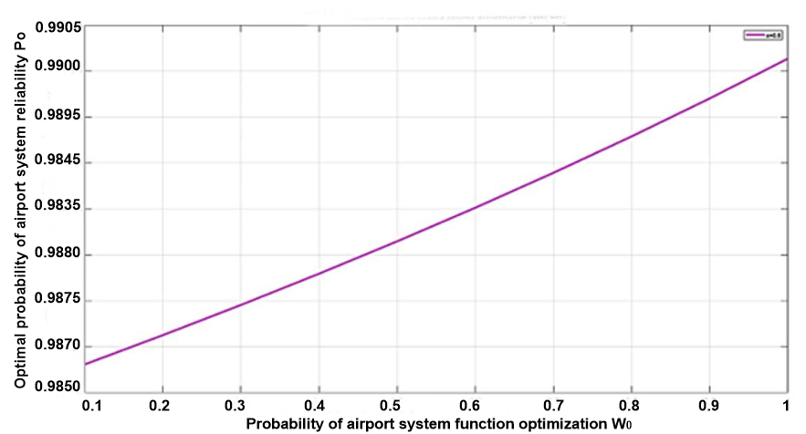
Figure 4. Dependence of indicators by type of information
W0=[0.23 0.08 10 0.33 0.04 0.03 0.14 0.12 6.83 0.05 0.45];Po=[0.450 0.990 0.995 0.532 0.444 0.025 0.143 0.580 0.078 0.600 0.600]
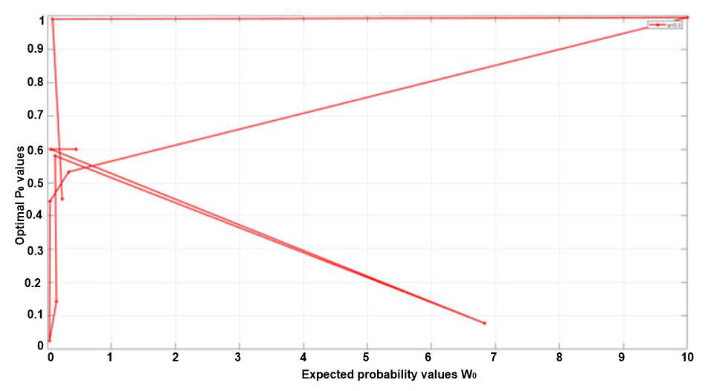
Figure 5. Forecast of optimal values $P_{0}$
The heuristic results of models Fig. 4 and 5 focus on optimizing the transmission and processing of information flows at Kosice Airport based on data collection, with an emphasis on the effective use of technological innovations introduced between 2020 and 2024.
The airport processes a large amount of data daily from reservation systems, air traffic control, and security checks. Effective analysis and filtering of this data is key to smooth and safe operations. Table 1 shows relevant information from airport facilities. The dependency of indicators by recipient type (passenger or LIS operator) determines their weight and priority hierarchy, ensuring timely and accurate delivery of critical data. Figure 5 shows the direct correlation between the optimization of information transfer and its accuracy within the monitored systems.
The quality and efficiency of the information flow to and from the AIS is evaluated using a prognostic model that graphically analyzes the process. Its onset from a minimum value (non-zero value) is evaluated up to a probability of $0.995$. From this course and within the processing of individual periods, we arrive at a recessionary state in the area of $0.555$, which indicates the exact weight and their submission within the LIS. For one task, which is a security system failure, the shutdown is radical, affecting other components of airport operations (police, control, service, etc.), returning to a value of $0.555$. In this way, it is possible to use an accurate model to optimize individual sectors and LIS components at the airport that operate within the framework of the precise preparation of the aircraft for the next flight (new destination).
If the airport decides to continue with the modernization of LIS technologies, predictive models can significantly contribute to the optimization of Kosice Airport, thereby strengthening its preparedness and flexibility in handling various situations in real time. This will improve the overall quality of services and safety. The designated information flow databases (Table 1) serve as the basis for the logistical and technical transfer of information, which is an integral part of successful passenger management and technical aircraft handling, as demonstrated by the example of Kosice Airport.
As part of the functionality assessment, Logit models require data to be categorized and converted into the logic of models, whether simulation or mathematical, so that in conjunction they show sufficient reserve even for errors, i.e., self-error with self-correction.
Furthermore, it is necessary to ensure the effectiveness of these systems because information system failures can significantly disrupt airport operations, prolong check-in times, and cause flight delays, thereby increasing passenger stress. Therefore, airports tend to have backup systems and contingency plans in place to minimize the impact of such failures. Data analysis or simulations at specific airports help to more accurately identify and address potential weaknesses, which is key to minimizing operational risks.

4 conclusions
This method allows the proposer or airport operator to create a precise solution when transitioning to new AI-supported information technologies. The limiting factor is their reliability (Optimization Theorem) and the effectiveness of electronic systems in the process of heavy air traffic. The presented method is not supported by legislation and is not currently covered by regulations, as AI is part of today's legal analyses to support overall air traffic management. For this reason, safety remains the only criterion for its application. Based on the analysis and modeling of airport information systems (CLIS), their reliability is key to the effective management and optimization of airport operations.
The maximum achievable probability of fault-free operation of the information system at Kosice Airport (AIS) was calculated based on the probabilities of failure of individual components and their interconnected functions. The results showed that modernization and investment in new information technologies are necessary to achieve the required level of reliability. The assessment and subsequent comparison of the required and existing failure probabilities showed a significant difference of ${2.10}^{-3}$, indicating a considerable need for improvement in the area of reliability.

Acknowledgments

The authors would like to thank the KEGA grant agency for supporting research work and co-financing the project KEGA 008TUKE-4/2025.

References
[Andronie 2018] Andronie, M., et al. Generative artificial intelligence algorithms in Internet of Things blockchain-based fintech management. Oeconomia Copernicana, 2024, Vol. 15, No. 4, pp. 1349-1381. https://doi.org/10.24136/oc.3283.
[Cavada 2017] Cavada, J.P., Cortes Carrillo, C., Rey, P.A. A simulation approach to modelling baggage handling systems at an international airport. Simulation Modelling Practice and Theory, 20217, Vol. 75, pp. 146-164. doi.org/10.1016/j.simpat.2017.01.006.
[Guo 2020] Guo, Y., Sun, Y. Flight safety assessment based on an integrated human reliability quantification approach. PloS ONE, 2020, Vol. 15, No. 4, e0231391. https://doi.org/10.1371/journal.pone.0231391.
[Harnicarova 2019] Harnicarova, M., et al. Study of the influence of the structural grain size on the mechanical properties of technical materials, Materialwissenschaft und Werkstofftechnik, 2019, Vol. 50, pp. 635-645. ISSN 0933-5137.
[Henke 2022] Henke, I., Esposito, M., della Corte, V., del Gaudio, G., Pagliara, F. Airport Efficiency Analysis in Europe Including User Satisfaction: A Non-Parametric Analysis with DEA Approach. Sustainability, 2022, Vol. 14, 283. https://doi.org/10.3390/su14010283.
[Jakubisinova 2025] Jakubisinova, J. Analysis and estimation of the effectiveness of causal airport systems (Analyza a odhad efektivnosti kauzalnych letiskovych systemov). Diploma thesis. Kosice: Technical University of Kosice, 2025. (in Slovak)
[Kierzkowski 2021] Kierzkowski, A., Kisiel, T. Feasibility of Reducing Operator-to-Passenger Contact for Passenger Screening at the Airport with Respect to the Power Consumption of the System. Energies, 2021, Vol. 14, No. 18, 5943. https://doi.org/10.3390/en14185943.
[Kovacikova 2023] Kovacikova, K., Novak Sedlackova, A., Novak, A., Remencova, T. The Quality of Airport Services in the Wake of the Covid-19 Pandemic. In: 2023 Smart City Symposium Prague (SCSP), Prague, Czech Republic, 2023, pp. 1-6. DOI: 10.1109/SCSP58044.2023.10146229.
[Kovacikova 2024] Kovacikova, K., Novak, A., Novak Sedlackova, A., Kovacikova, M. Evaluating passenger satisfaction: a comparative analysis of low-cost and traditional airlines. Transportation Research Procedia, 2024, Vol. 81, pp. 77-83. https://doi.org/10.1016/
j.trpro.2024.11.009.
[Kurdel 2018] Kurdel, P., et al. Control of autonomous navigational ergative transport objects. In: Safety and transport 2018: Theory and practice in safety and crisis management in transport. Brno (Czech Republic): Academic publishing house CERM, 2018, pp. 572-579. ISBN 978-80-7623-002-6.
[Lazar 2018] Lazar, T., Kurdel, P., Novak Sedlackova, A. Precision efficiency of autonomous navigation ergative transport complexes. In: Proc. of Improving safety and quality in civil aviation. Zilina: University of Zilina, 2018, pp. 81-84. ISBN 978-80-554-1418-8.
[Liu 2021] Liu, Y., Hansen, M., Ball, M.O., Lovell, D.J. Causal analysis of flight en route inefficiency. Transportation Research Part B: Methodological, 2021, Vol. 151, pp. 91-115. ISSN 0191-2615. https://doi.org/10.1016/j.trb.2021.07.00.
[Liu 2023] Liu, B., Lai, H., Kan, S., Chan, C. Camera-Based Smart Parking System Using Perspective Transformation. Smart Cities, 2023, Vol. 6, pp. 1167-1184. https://doi.org/10.3390/smartcities6020056.
[Nahornyi 2022] Nahornyi, V., et al. Method of Using the Correlation between the Surface Roughness of Metallic Materials and the Sound Generated during the Controlled Machining Process. Materials, 2022, Vol. 15, Art. no. 823. https://doi.org/10.3390/ma15030823.
[Panda 2014] Panda, A., Prislupcak, M., Pandova, I. Progressive Technology Diagnostics and Factors Affecting Machinability. Applied Mechanics and Materials, 2014, Vol. 616, pp. 183-190. ISSN 1660-9336.
[Panda 2020] Panda, A., et al. A novel method for online monitoring of surface quality and predicting tool wear conditions in machining of materials. The International Journal of Advanced Manufacturing Technology, 2020, Vol. 123, No. 9-10, pp. 3599-3612. DOI: 10.1007/s00170-022-10391-0.
[Panda 2021] Panda, A., et al. Increasing of wear resistance of linear block-polyurethanes by thermal processing methods. MM Science Journal, 2021, No. October, pp. 4731-4735. DOI: 10.17973/MMSJ.
2021_10_2021018.
[Panda 2022] Panda, A., et al. Ecotoxicity Study of New Composite Materials Based on Epoxy Matrix DER-331 Filled with Biocides Used for Industrial Applications. Polymers, 2022, Vol. 14, No. 16, Art. no. 3275. https://doi.org/10.3390/polym14163275.
[Pandova 2020] Pandova, I., et al. A study of using natural sorbent to reduce iron cations from aqueous solutions. International Journal of Environmental Research and Public Health, 2020, Vol. 17, No. 10., Art. no. 3686. doi.org/10.3390/ijerph17103686.
[Remencova 2021] Remencova, T., Novak Sedlackova, A. The Approach to Evaluation of the economic and operational Indicators of selected Regional Airports in the Countries of Central Europe. Transportation Research Procedia, 2021, Vol. 59, pp. 154-165. DOI: 10.1016/j.trpro.2021.11.107.
[Shone 2021] Shone, R., Glazebrook, K., Zografos, K.G. Applications of stochastic modeling in air traffic management: Methods, challenges and opportunities for solving air traffic problems under uncertainty. European Journal of Operational Research, 2021, Vol. 292, No. 1. https://doi.org/10.1016/j.ejor.2020.10.039.
[Sukhodub 2018] Sukhodub, L., et al. The design criteria for biodegradable magnesium alloy implants. MM Science Journal, 2018, No. December, pp. 2673-2679. DOI: 10.17973/MMSJ.2018_12_201867.
[Sukhodub 2019] Sukhodub, L., Panda, A., Sukhodub, L., Kumeda, M., Baron, P. Hydroxyapatite and zinc oxide based two-layer coating, deposited on Ti6Al4V substrate. MM Science Journal, 2019, No. December, pp. 3494-3499. DOI: 10.17973/
MMSJ.2019_12_2019030.
[Tikhonov 2022] Tikhonov, A., Sazonov, A. Implementation of Digital Management System for the Enterprises Development and Distribution in Aviation Industry. The Journal of Distribution Science, 2022, Vol. 20, No. 9, pp. 39-46. https://doi.org/10.15722/
jds.20.09.202209.39.
[Tutak 2024] Tutak, M., et al. Predicting Methane Concentrations in Underground Coal Mining Using a Multi-Layer Perceptron Neural Network Based on Mine Gas Monitoring Data. Sustainability, 2024, Vol. 16, No. 19, 8388. doi.org/10.3390/su16198388.

contacts:
Prof. Ing. Anton Panda, PhD.
Faculty of Manufacturing Technologies with a seat in Presov,
Technical University of Kosice,
Sturova 31, 080 001 Presov, Slovakia
e-mail: anton.panda@tuke.sk

